Activity sheet 5.7 – Presenting and interpreting experimental results
Table to collect data on number of snails in garden
Temperature (⁰C) | Number of snails found
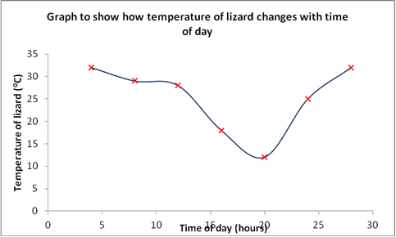

Graph to show the relationship between growth of plant and amount of fertilizer added.
